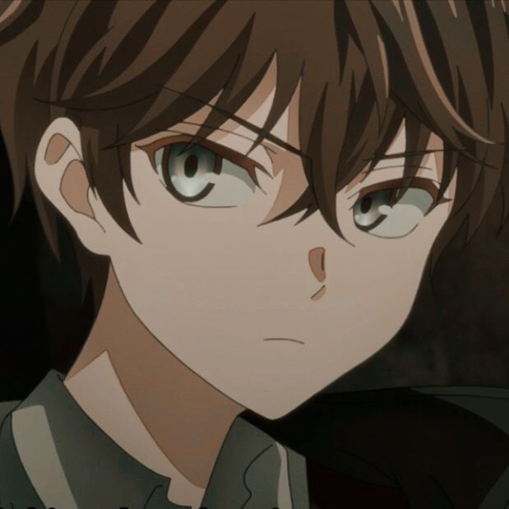

Wind changes the weather and revolutions change the countries. Life sure is a box of chocolates.